

Full view of the first physical sector

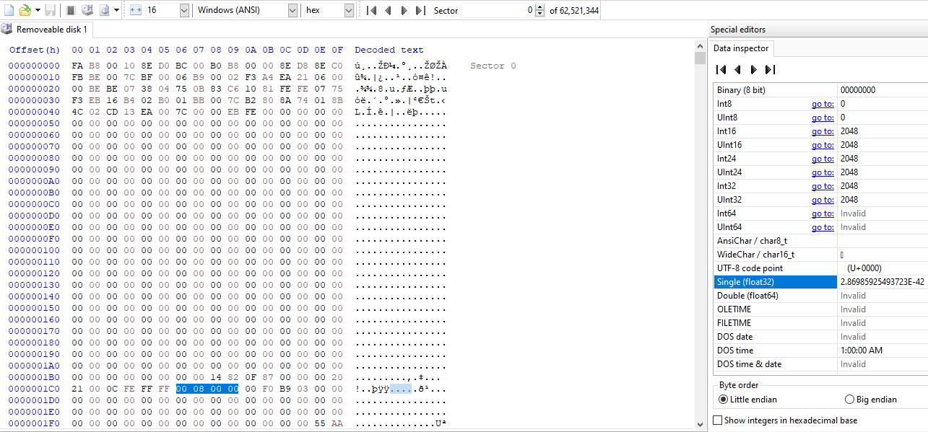

This is a MBR sector, not a BPB sector. If this is a BPB sector, there would be the word “FAT” in somewhere in the sector. Since it’s a MBR sector, the 4 bytes starting with offset 0x1C6 indicate the starting address of the BPB (which is the logical sector in this case). We see that it’s 0x00000800 (little endian) which is 2048. We then go to sector 2048

Full view of the first **logical** sector:

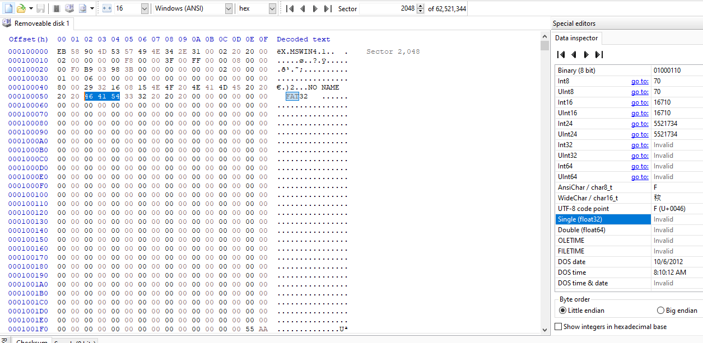

Number of reserved sector (2 bytes at address 0x0E) including the MBR:

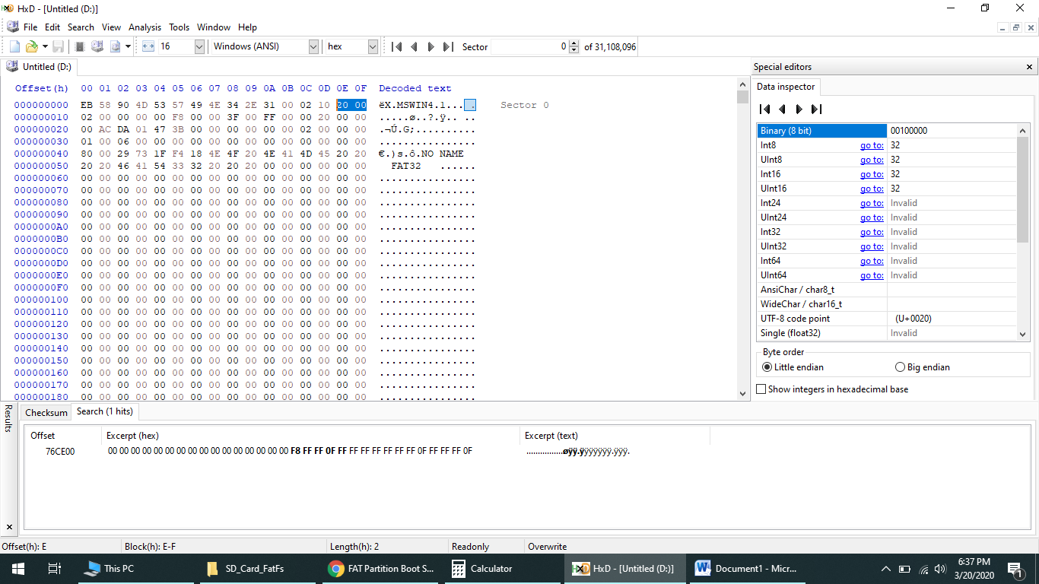

0x0020 = 32 sectors

Number of sector per FAT table (4 byte at 0x24:

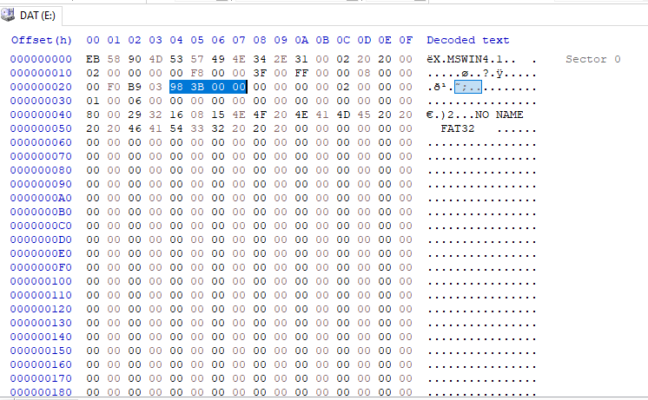

Little Endian: 0x00003B98 = 15256

FirstDataSector sector (also called root directory) contains information about the file in the system:

First Data Sector = #reserved sector + 2 * #sector per FAT table + BPB offset =

32 + 2*15256 + 2048 = 30592

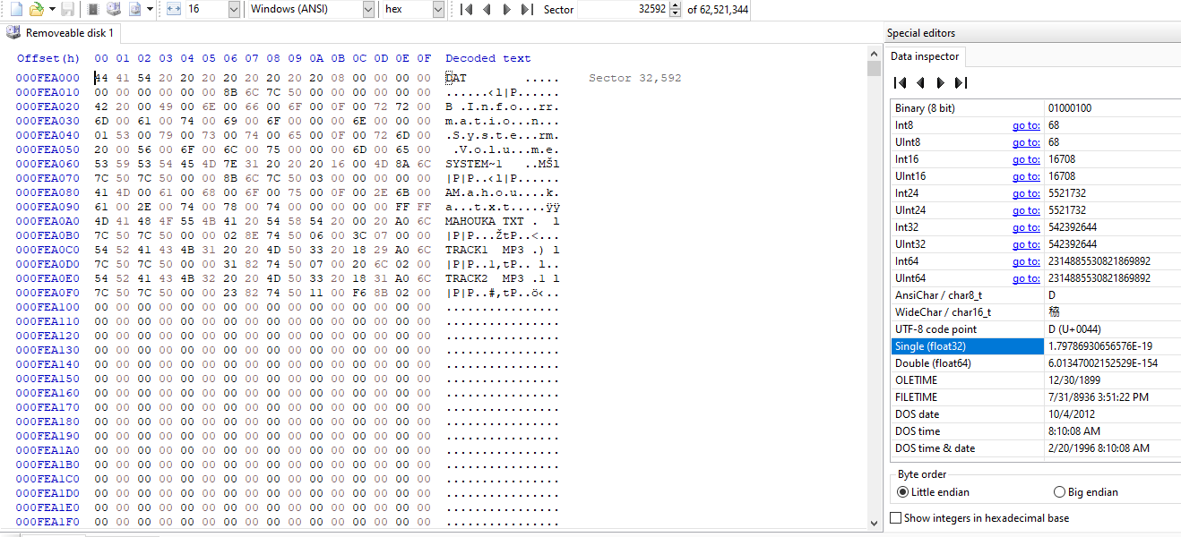

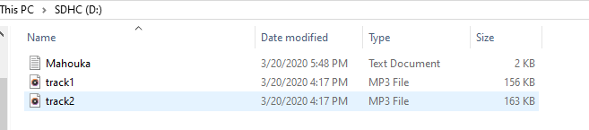

**INSIDE ROOT FOLDER DIRECTORY**

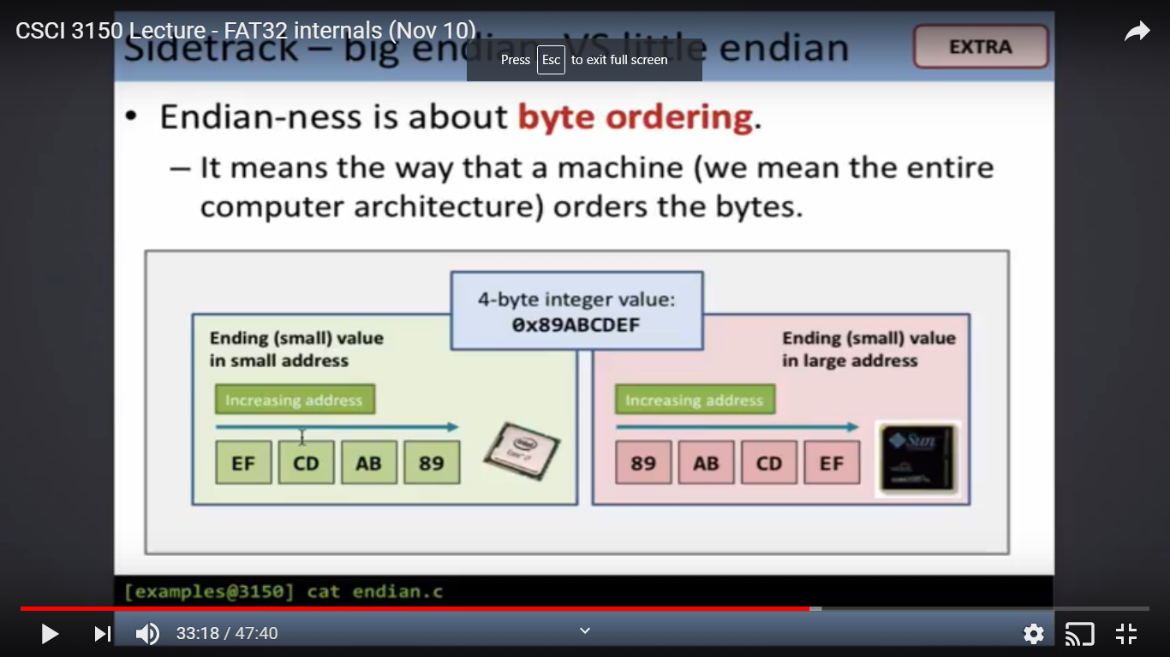

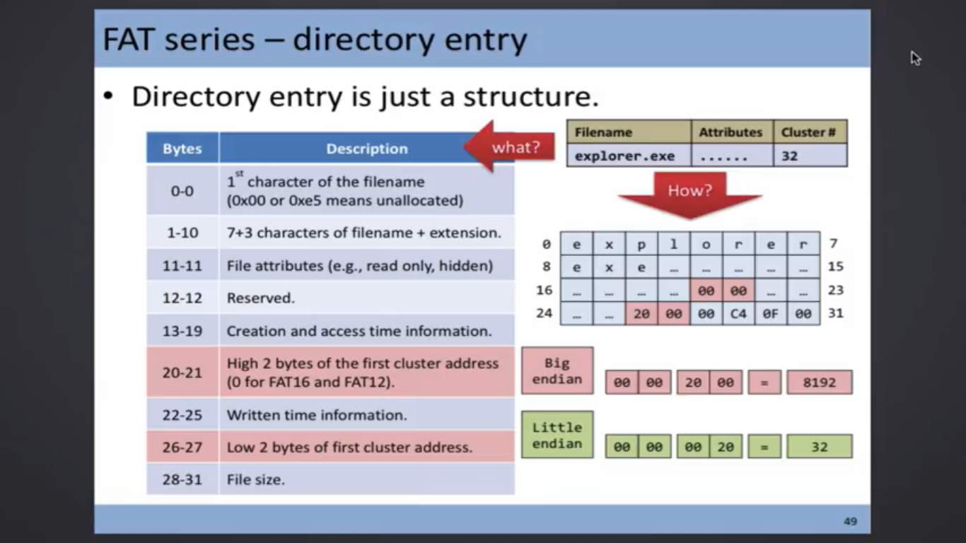

Each directory entry is 32-bit.

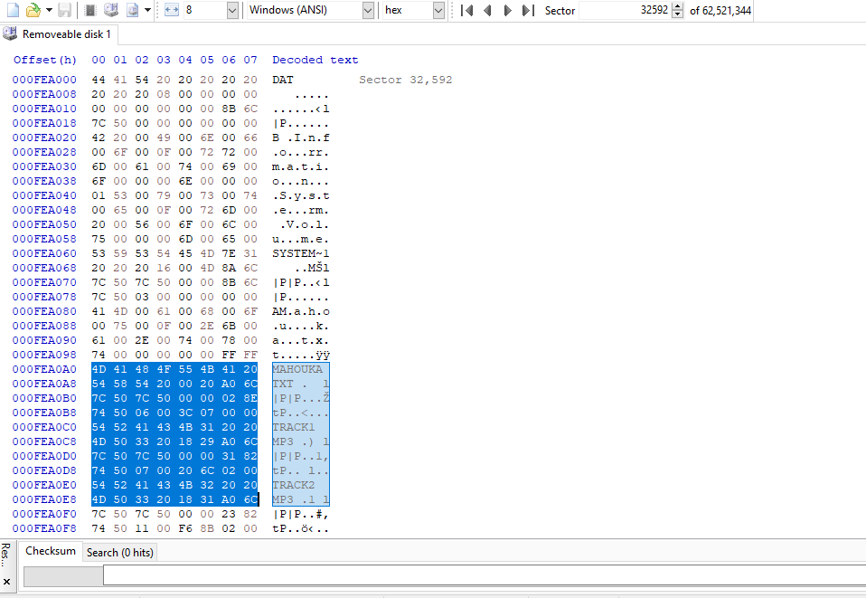

As an example:

File name = mahouka. Extension = txt

N=First cluster address = 0x0000 0006 in this case (little endian)

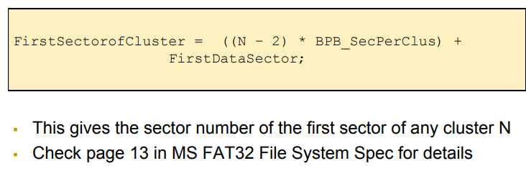

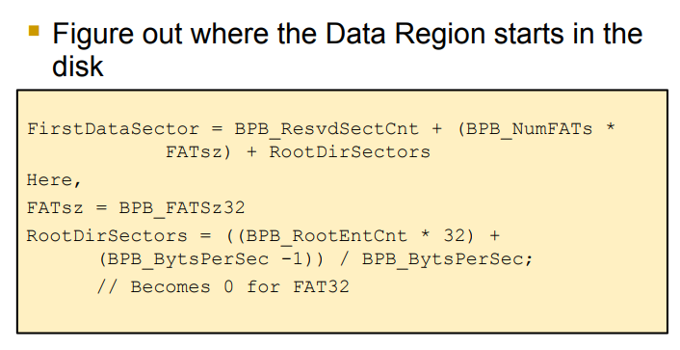

Note: SD card format to 16384 byte per cluster in this case (32 sectors of 512 bytes each).

* Number of reserved sector including MBR BPB_ResvdSectCnt (found in MBR = 32 earlier)
* Number of FAT. Found in MBR (2 in this case which is typical)
* FATsz (FAT table size) = 15256 as found above:

Sector per cluster BPB_SecPerClus = 16384 / 512 = 32

FirstDataSector = 32+ 2*15256 = 30544

FirstSector ofCluster = ((6-2)*32) +30544= 30672

This is a logical number. The physical number add the BPB offset to it :

30672+2048 = 32720

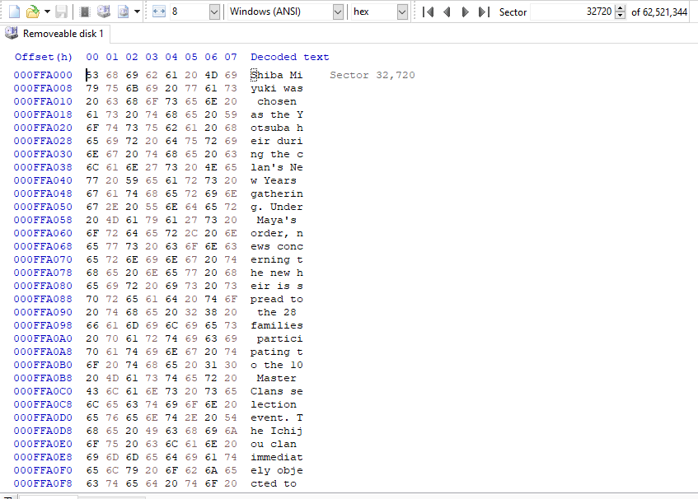

**FAT32 TABLE TRAVERSAL**

Since the number of reserved sectors are 32 (calculated above). The FAT table starts on sector 32

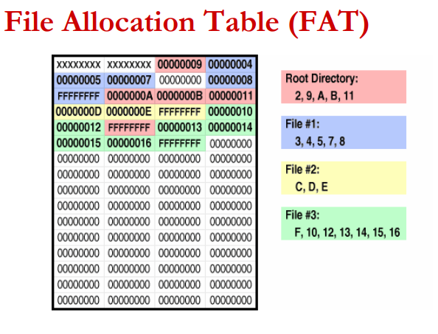

Each 4 bytes represent (hence FAT32) the value of the **NEXT** cluster unless the value is 0xFFFF FFFF which indicates the last sector being the last sector.

To repeat the above point FAT table starts after reserved sector. From the beginning we know the number of rserved sector + BPB is 32.

FAT location (sector #) = #reserved sector + BPB offset = 32 + 2048 = 2080

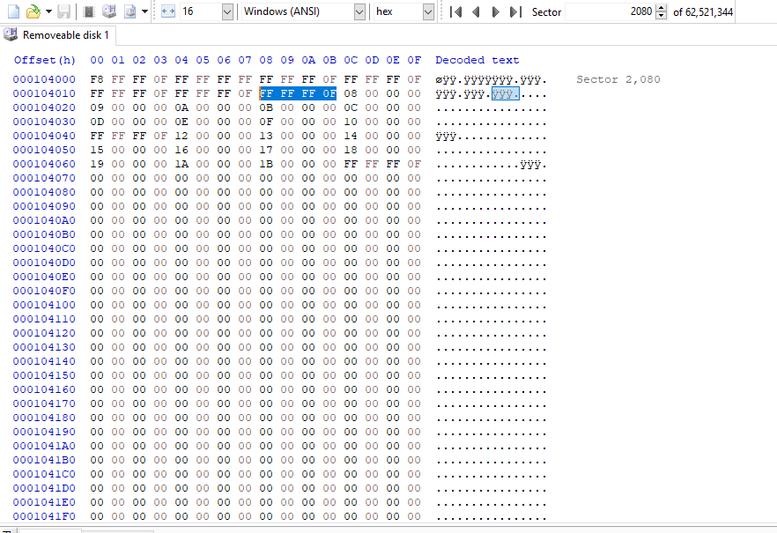

Figure Mahouka.txt sectors

For our file,

* Mahouka.txt first cluster is at 0x0000 0006 (highlighted above). Since the value is 0x0FFFFFFF, this means that this is also the only cluster allocated of the file.
* Track1.mp3 first cluster offset is at 0x0000 0007
* Track2.mp3 first cluster offset is at 0x0000 0011 (17 in dec)

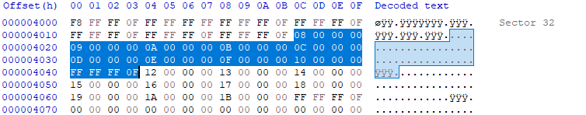

Figure Track1.mp3 sector

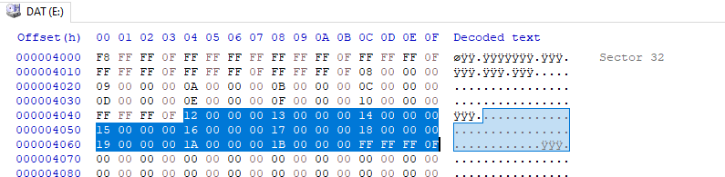

Figure Track2.mp3 sector

First 5 bytes:  
